Civil war in Liberia

UNSC Resolution: | 1478
Date of adoption: | 6-May-2003
Operative paragraph: | 22
Demand number: | 1478,2211

Sarah-Myriam Martin-Brûlé

Wording of demand

strengthen the measures they have taken to combat the spread of small arms and light weapons and mercenary activities and improve the effectiveness of the ECOWAS moratorium

List of addressees of the demand

Government of Liberia

Short-term compliance

Description of the addressee(s)’ conduct

.
“In spite of international initiatives designed to curb foreign supply, such as the
ECOWAS Moratorium on Importation, Exportation and Manufacture of Light Weapons
in West Africa, the smuggling of weapons from international sources continues to
make headlines. For the vast majority of groups, however, the recirculation of
existing stockpiles—in particular of official state-owned weapons—through theft,
seizure, and corruption is a primary source of armament. State-owned weapons
often make their way into the hands of Nigerian groups (see Chapter 1) and
elsewhere, frequently with the help of corrupt politicians or members of the security
forces.”

Nicolas Florquin and Eric G. Berman. 2005. “Armed and Aimless : Armed Groups, Guns and Human Security in the ECOWAS Region”. Small Arms Survey Report. May.
http://www.smallarmssurvey.org/files/sas/publications/b_series_pdf/AA/A&A-full_manuscript.pdf

“The Ivorian army100 as well as progovernment militias such as the FLGO101 relied on Liberian mercenaries in their fight against the rebels. French officers refer to these as ‘Lima’ after the radio call sign ‘L’ for Liberia, a term subsequently used by the Ivorian government to give the impression of a gulf between it and these ‘Liberians’. Liberian mercenaries based in Côte d’Ivoire formed the backbone of the Movement for Democracy in Liberia (MODEL, see Liberia) that emerged in mid-2003 to fight Charles Taylor alongside the Liberians United for Reconciliation and Democracy (LURD).102 Many fighters were allegedly recruited from areas close to the Liberian border (where many Liberian nationals had lived for several years), including the Nicla refugee camp, where young refugees reportedly were offered CFA F 10,000 (about USD 17 at the time) to become fighters.”
(...)
“In early 2003, an estimated 1,500–3,000 such Liberian fighters were operating in Côte d’Ivoire, 1,000 of whom subsequently left for Liberia to fight with MODEL and LURD against Taylor.”
(…)

“LURD signed the CPA in Accra and participated in the DDRR process. It officially disbanded on 3 November 2004 following the end of the disarmament process, but remains very much an organized faction and is still considered powerful and potentially dangerous, despite its leadership problems. There is speculation among Liberians that LURD may not fully disband until after the scheduled October 2005 presidential
elections.”

(…)
“Both rebel and government forces relied extensively on light weapons for tactical reasons. Combat would quite systematically begin with rocket-propelled grenade launchers (RPGs) shelling followed by small arms fire during the second phase.33 The June–July 2003 offensive against Monrovia is a well-documented example of heavy mortar shelling by LURD.34 Other light weapons in the hands of rebels included RPO-type grenade launchers, British-made 60 mm and 81 mm mortars, and DSHK
12.7 mm heavy machine guns, as well as SA-7/Strella surface-to-air missiles. 35 The AFL and pro-government groups used universal and generalpurpose machine guns and RPG’s.
(...)
“LURD captured FN FAL rifles, AKM assault rifles, RPO-type grenade launchers, and SA-7 surface-to-air missiles from government forces or government-backed armed groups.37 LURD also obtained weapons from ‘unpaid military or police personnel from both Liberia and Guinea’.”
(...)

The Taylor government used extra-budgetary revenue and logistics (ships, ports, etc.) of the logging and mineral extraction industries to import weapons in contravention of the UN arms embargo directed at the country.47 Since the end of the war, however, external support appears to have ended.”

Nicolas Florquin and Eric G. Berman. 2005. “Armed and Aimless : Armed Groups, Guns and Human Security in the ECOWAS Region”. Small Arms Survey Report. May.
http://www.smallarmssurvey.org/files/sas/publications/b_series_pdf/AA/A&A-full_manuscript.pdf

Assessment

Short-term compliance
X No or marginal compliance (1) | Medium low compliance (2) | Medium high compliance (3) | Full or almost full compliance (4)

Considerations underlying the assessment

Within the six months following the adoption of this agreement, the government of Liberia did not significantly strengthen the measures they have taken to combat the spread of small arms and light weapons and mercenary activities. It did not improve the effectiveness of the ECOWAS moratorium.

Medium-term compliance

Description of the addressee(s)’ conduct

“As about 2,000 extra UN troops arrived in Liberia in late December, a contingent of approximately 270 Pakistani soldiers was intercepted at the Po River Bridge by LURD fighters in late November. LURD officials tried to take advantage of the situation, demanding senior positions in government before they would allow the peacekeepers to pass. However, they finally agreed to let an advance contingent of 125 Pakistani peacekeepers deploy in the strategic Kle Junction area of Tubmanburg County. This led to the stationing of troops deep inside rebel-held territory and the establishment of new UN bases at Buchanan and Gbarnga. UNMIL has since deployed more troops across the country and currently has close to 11,500 peacekeepers on the ground. The United Nations Mission in Sierra Leone (UNAMSIL) also boosted its presence in December along Sierra Leone’s eastern border − under an operation codenamed Blue Vigil − in an effort to prevent arms smuggling during the suspended disarmament process”

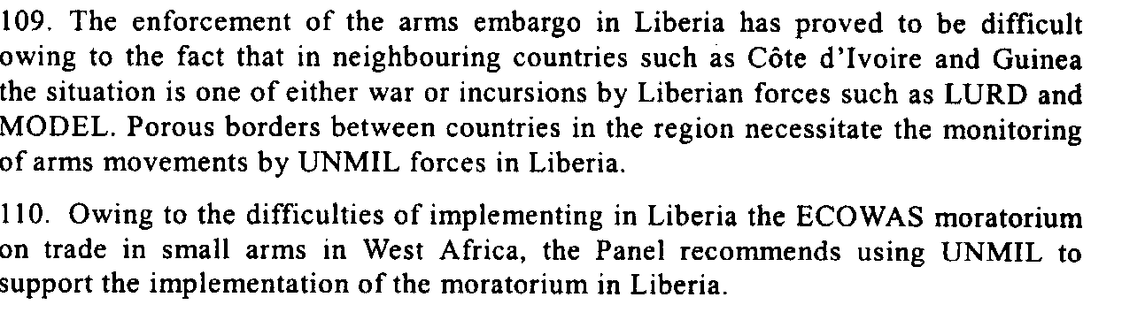
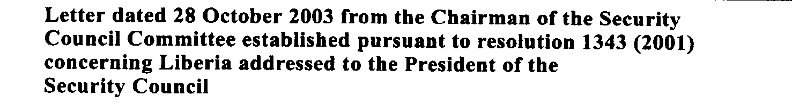

“UN officials have no estimate of how many weapons or fighters may have already passed back and forth between Liberia and its neighbours, but the flow is unlikely to stop anytime soon.54 This was made abundantly eviden following the outbreak of renewed violence in Côte d’Ivoire in November 2004, when reports emerged that the Ivorian government was recruiting Liberian mercenaries to support President Laurent Gbagbo (National Chronicle, 2004). Similarly, in September 2004 it was reported that a rebel group, led by a former associate of Charles Taylor, was paying Liberian fighters USD 150–USD 200 to join him in his bid to overthrow the Guinean government (IRIN, 2004b).”
Nicolas Florquin and Eric G. Berman. 2005. “Armed and Aimless: Armed Groups, Guns, and Human Security in the ECOWAS Region. Small Arms Survey.
http://www.smallarmssurvey.org/files/sas/publications/b_series_pdf/AA/A&A-full_manuscript.pdf

“Following the end of the Taylor regime, trafficking in arms ceased, with the last shipment of arms intercepted at Robertsfield International Airport in August 2003. On the other hand, the small-scale trading in arms intensified with arms and ammunition being smuggled to Liberia from neighboring countries in order to be surrendered to the disarmament, demobilization, rehabilitation and reintegration process (December 2003-October 2004).102 However, as there is no evidence of the involvement of organized criminal groups in the small arms trade in West Africa in general,103 there also is no indication that these groups would be involved in the cross-border movement of weapons for the purpose of “selling” them to the weapons collection programmes.”

Teran, Nika Stražišar. 2007. “Peacebuilding and Organized Crime: The Cases of Kosovo and Liberia” Working Paper. Swiss Peace Foundation.
http://www.swisspeace.ch/typo3/fileadmin/user_upload/pdf/Working_Paper/WP_1_2007_Kosovo_und_Liberi_neu.pdf

Assessment

Medium-term compliance
X No or marginal compliance (1) | Medium low compliance (2) | Medium high compliance (3) | Full or almost full compliance (4)

Considerations underlying the assessment

Within the two years following the adoption of this agreement, the government of Liberia did not significantly strengthen the measures they have taken to combat the spread of small arms and light weapons and mercenary activities. It did not improve the effectiveness of the ECOWAS moratorium

Depth of demand

Assessment

Level of depth of demand
Low depth of demand (1) | Medium depth of demand (2) | X High depth of demand (3)

Considerations underlying the assessment

The use of small arms and light weapons and mercenary activities ensured the demand addressees survival and it impacted on its chance to win power in the aftermath of the civil war.

Level of confidence about coding decisions

Level of confidence about coding decision
Extremely high | High | X Moderate

Comments to IPI (if any)

